 Project Report Template

Thyroid detection using machine learning

**1.INTRODUCTION**

* 1. **Overview :**

Data collection: Gathering a dataset of patient records, including medical

History, symptoms and diagnostic tests results.

Data pre processing: Cleaning the dataset, handling missing values, and transforming the data into a suitable format for machine learning algorithms.

Feature selection: identifying the most relevant features for classification, based on their correlation

1.2.Purpose:

Our aim is to accurately identified thyroid decease and to rectify it.

The thyroid produces two hormones, triiodothyronine(T3) and thyroxine(T4), which help regulate metabolism and influence a wide range of bodily functions, including heart rate, body temperature, and energy levels.

These hormones are essential for normal growth and development in children and for maintaining proper bodily functions in adults. An underactive or overactive thyroid gland can lead to a variety of health problems, including fatigue, weight gain or loss, and changes in mood and cognition.

**2. Problem Definition & Design Thinking :**

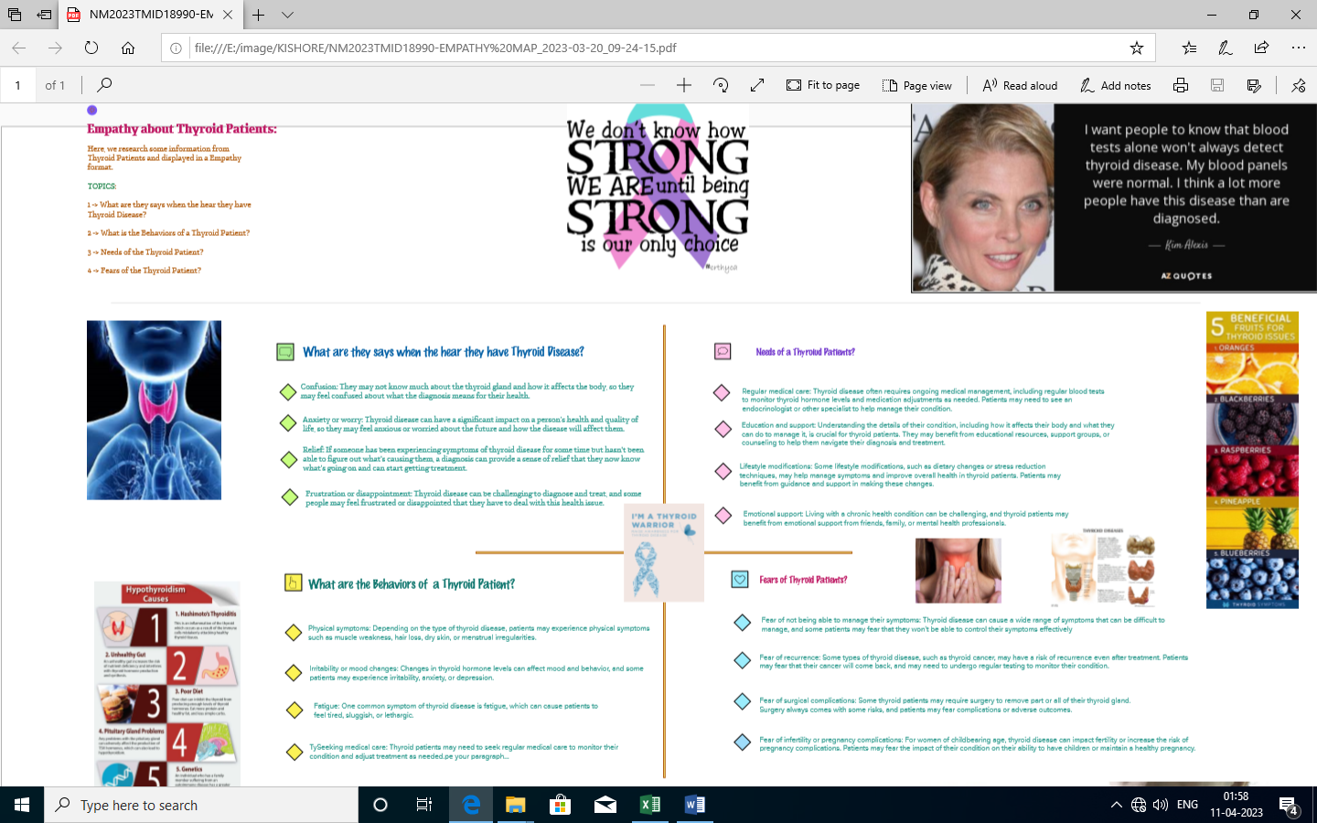2.1 Empathy Map:

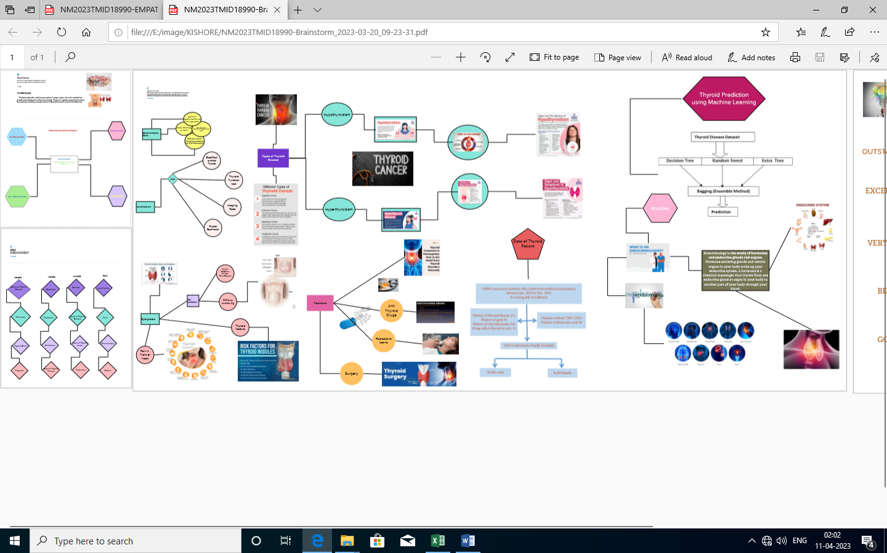 2.2 Ideation & Brainstorming Map:

**3. RESULT :**

3.1 Data Model:

|  |  |
| --- | --- |
| **Object name** | **Fields in the Object** |
| 1.Logistic regression  2.Svm  3.Knn  4.Decision tree  5.Random forest | |  |  | | --- | --- | | Field label | Data type | | 1.classifier  2.classifier  3.classifier  4.classifier  5.classifier | float  float  float  float  float | |

3.2 Activity & Screenshot :

Thyroid DD.ipynp

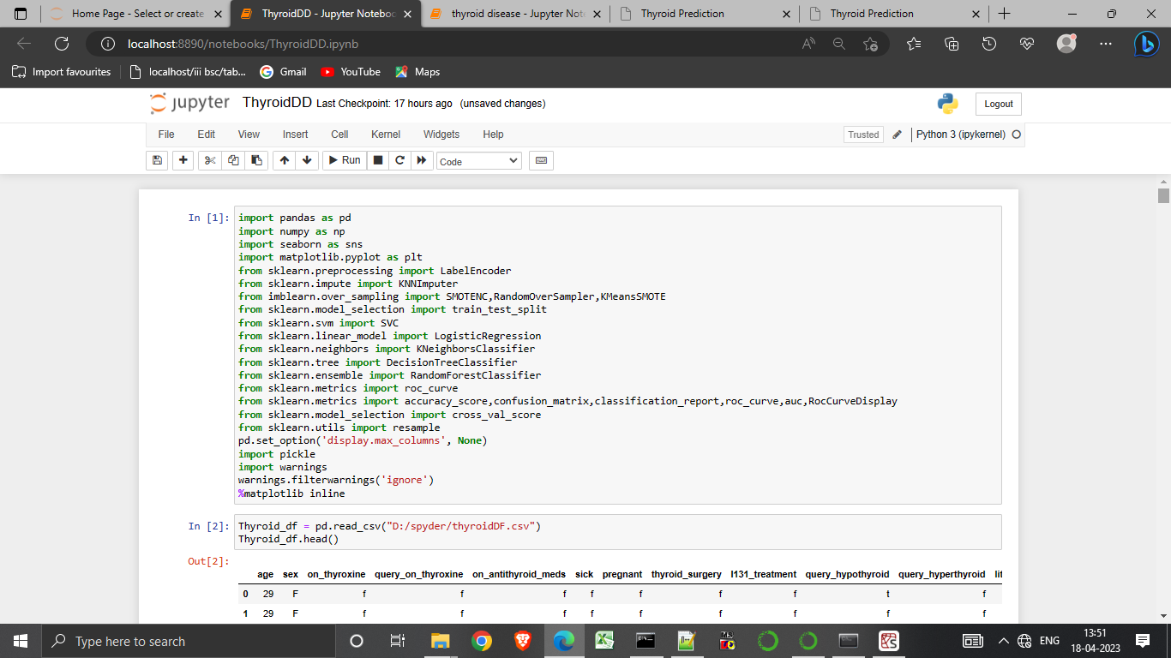

1.First we importing libraries like pandas, numpy, matplotlib etc.

2.Now we Replacing”?” with nan*.

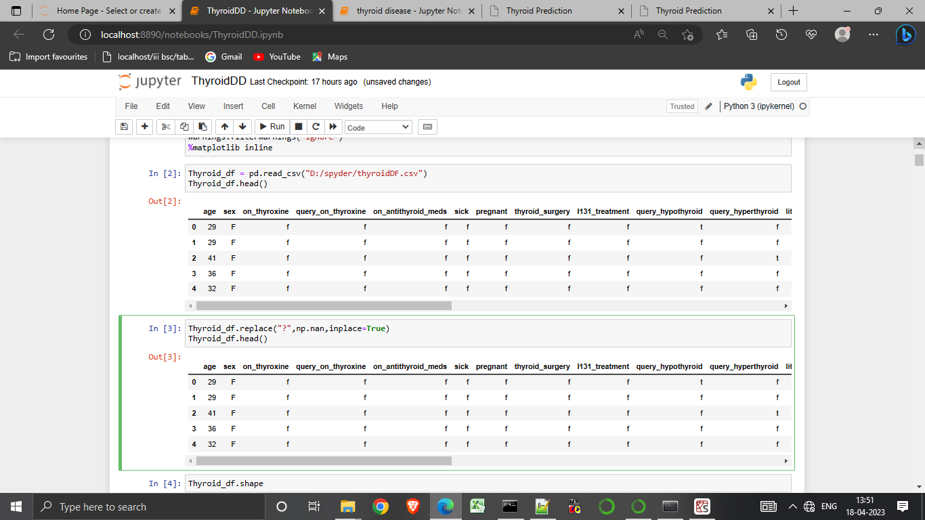

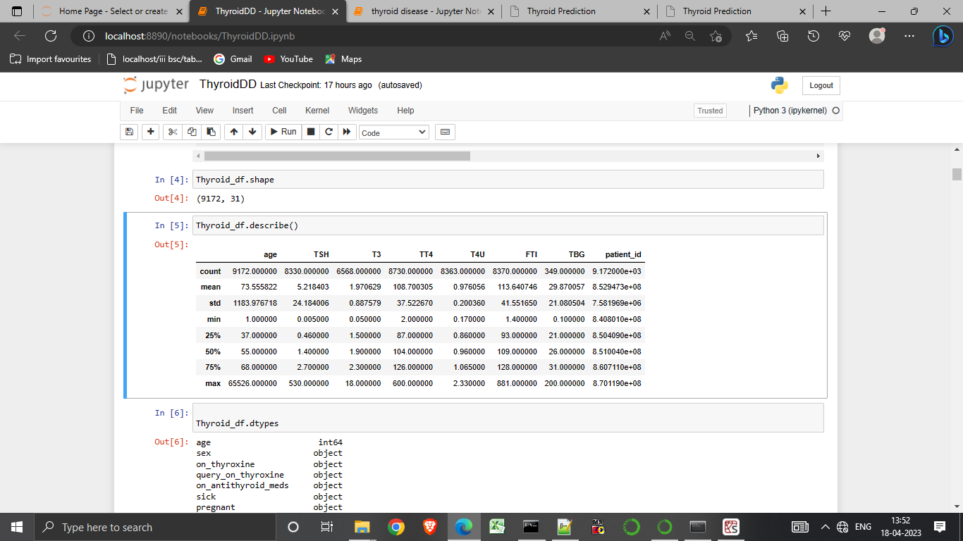

3.using describe function to display the data sets.

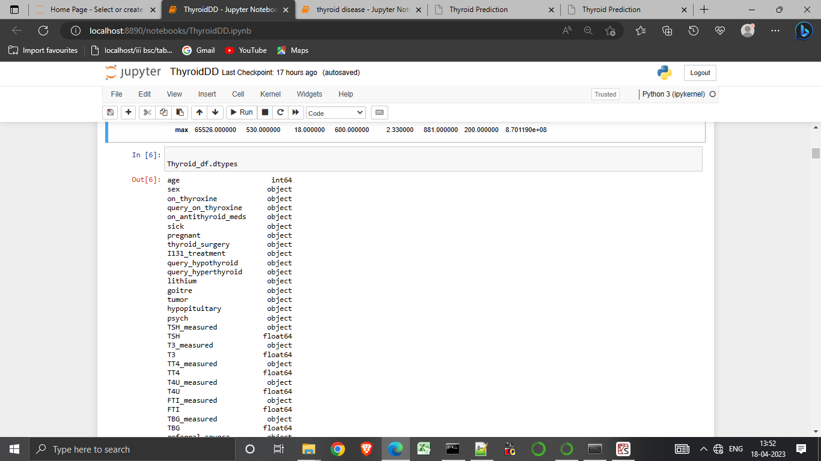

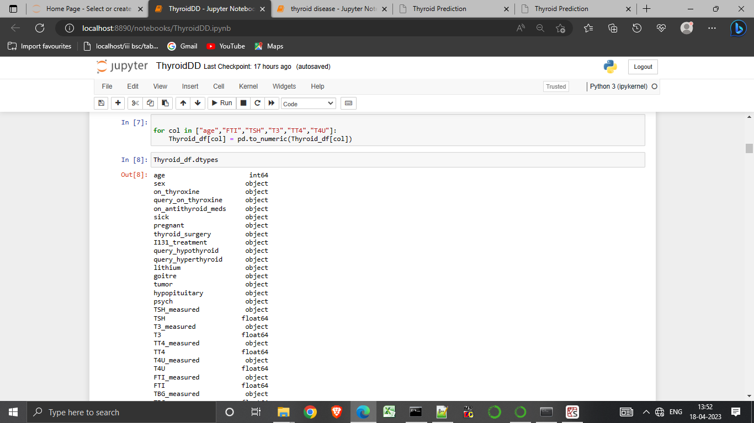

4.We imputing the 5 columns in col.

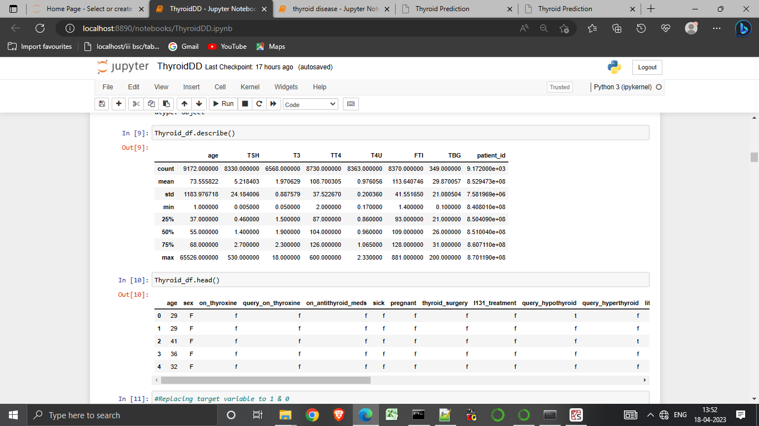

5.Using head () function to display the columns heads.

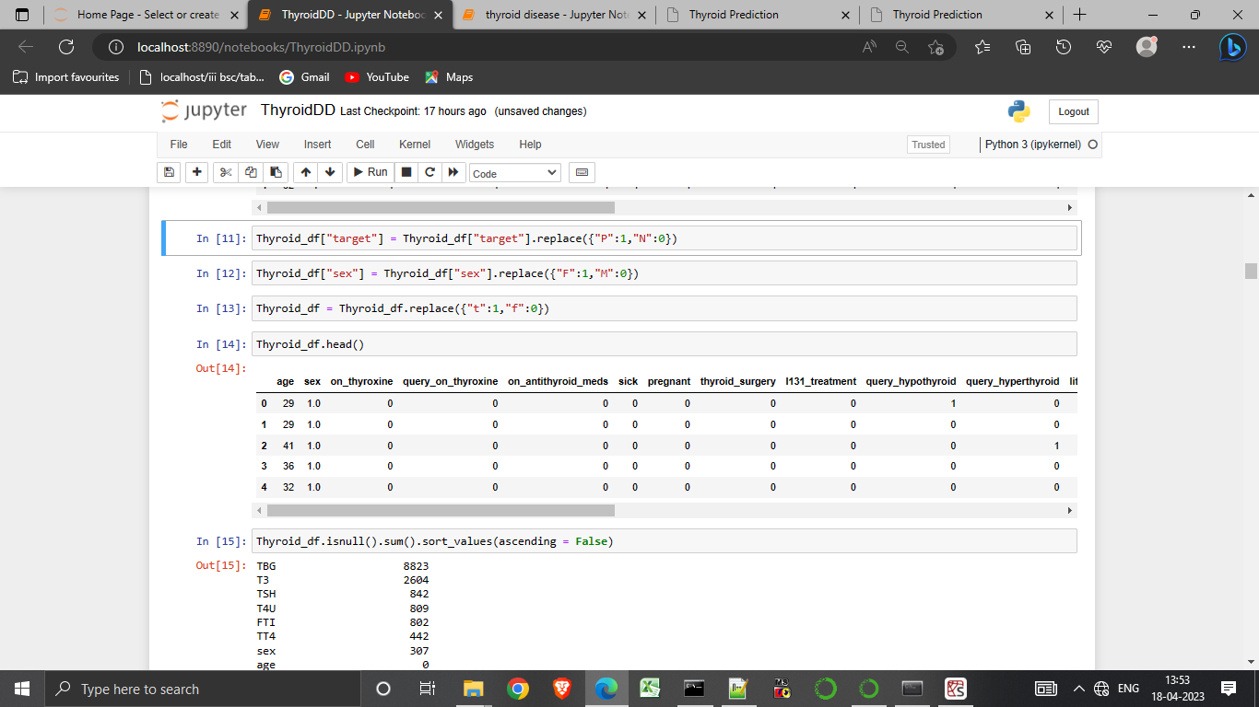

6.Replacing target variable into 1&0.

7.Using null function to show empty sets.

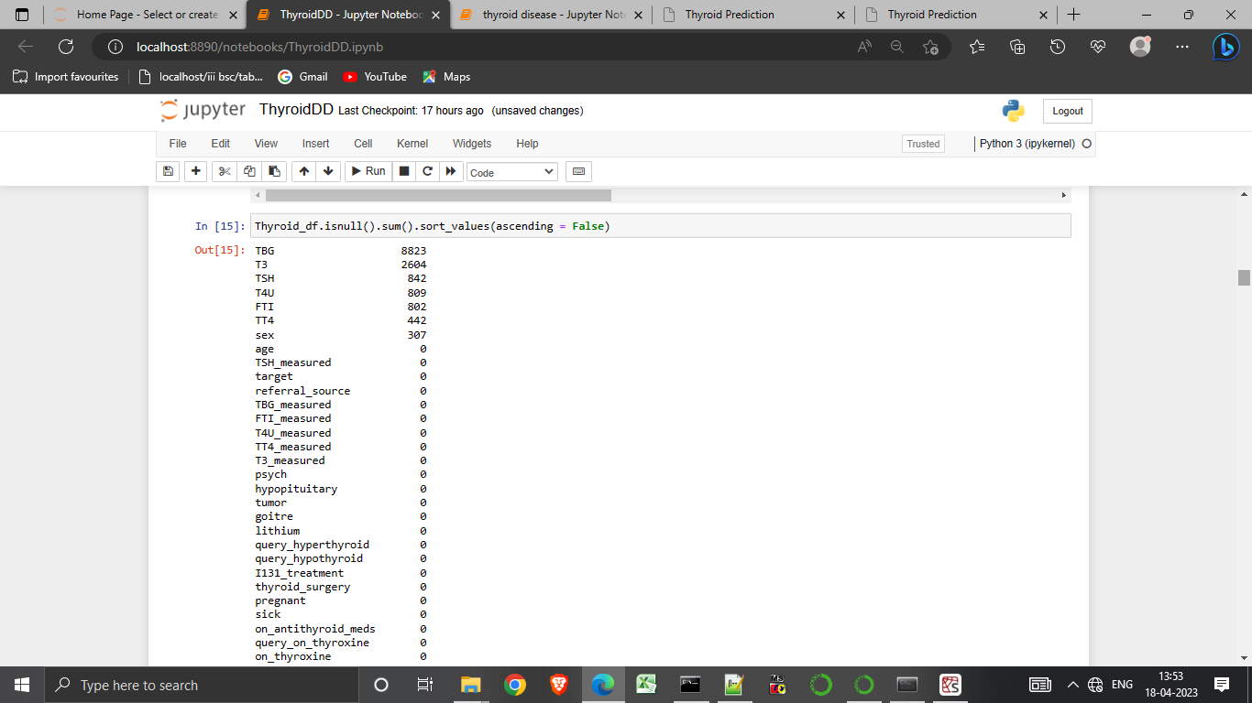

8. We showing plot heat map to check the null values.

9.Using ”cbar=flase” does not show the color axis.

10.Using plot show to display the plot.

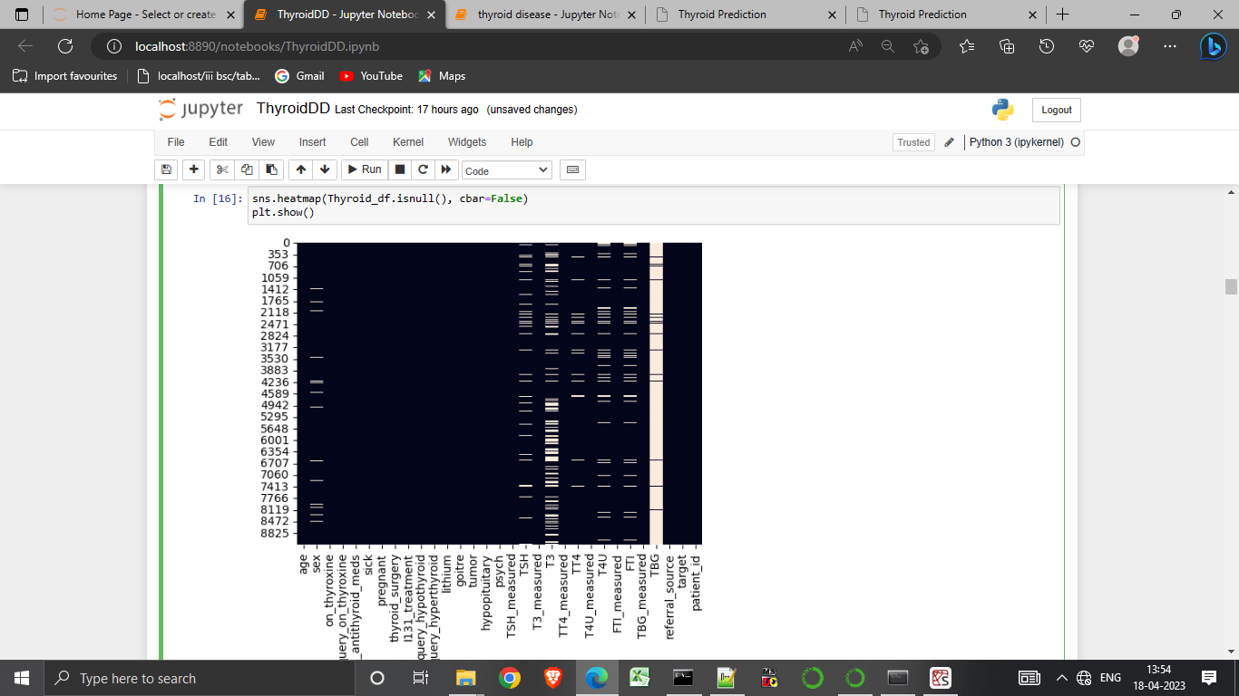

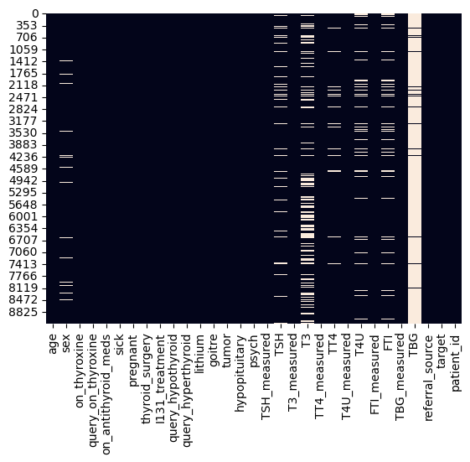

11.Use the ”for” loop for the filling.

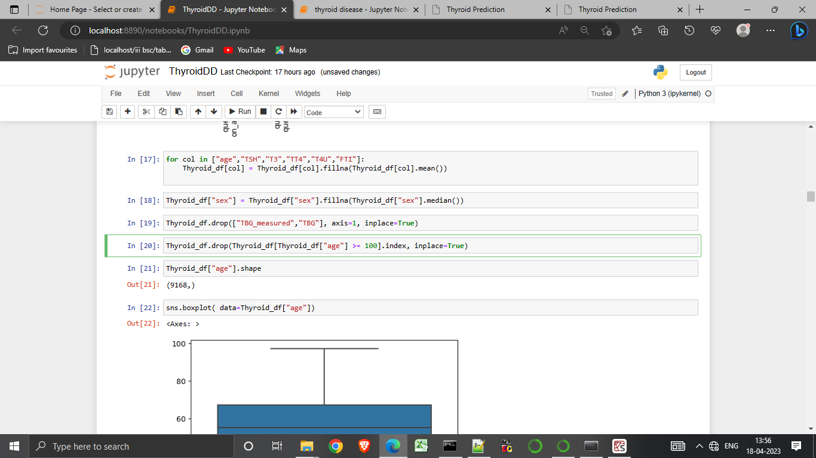

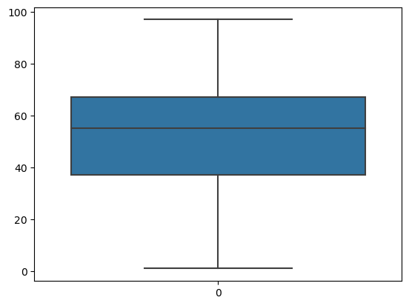

12. We taking age as an input to form the sns plot .

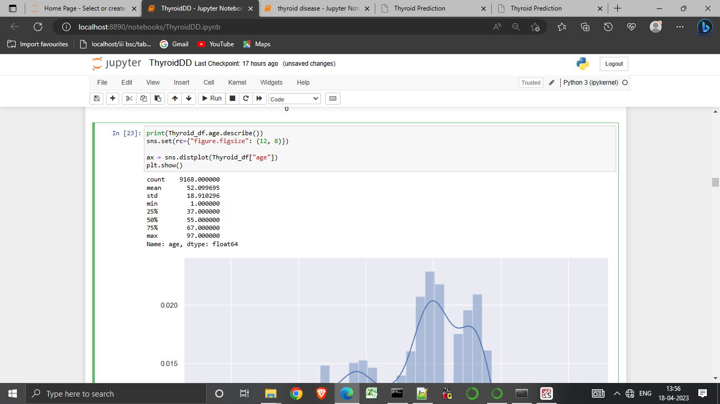

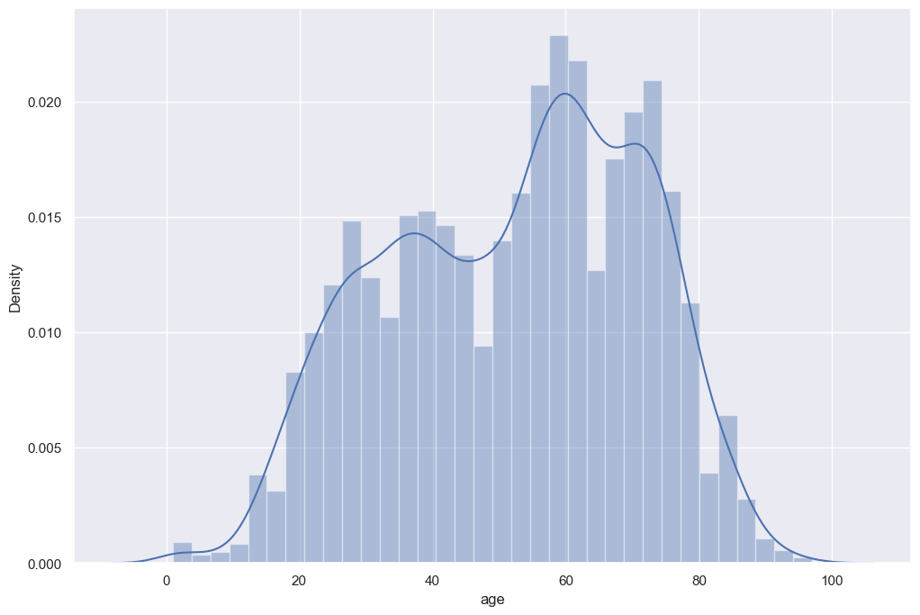

13. We describe the remaning sets.

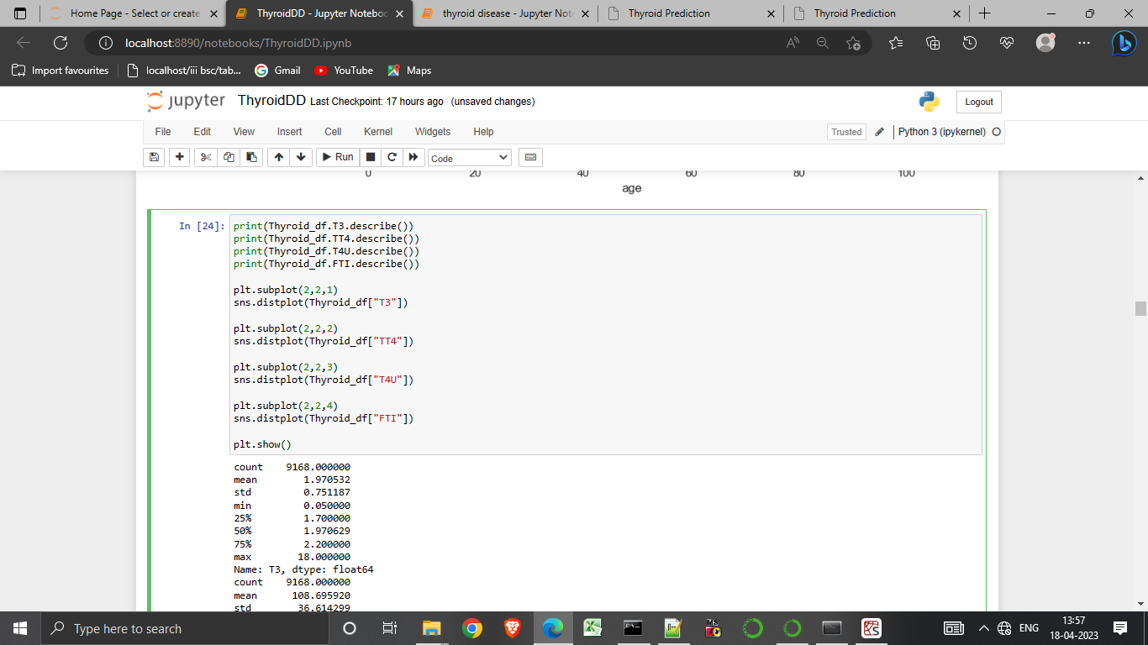

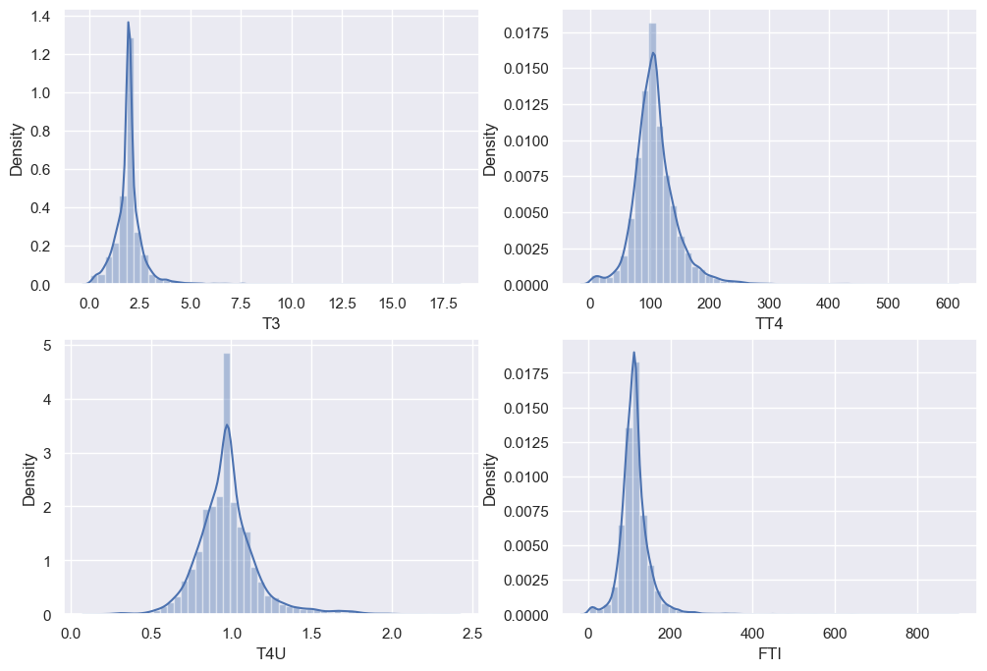

14.get counts of 0’s and 1’s in the ‘target’ variable using “value_counts()”.

15.We store the values is “class_frequency”.

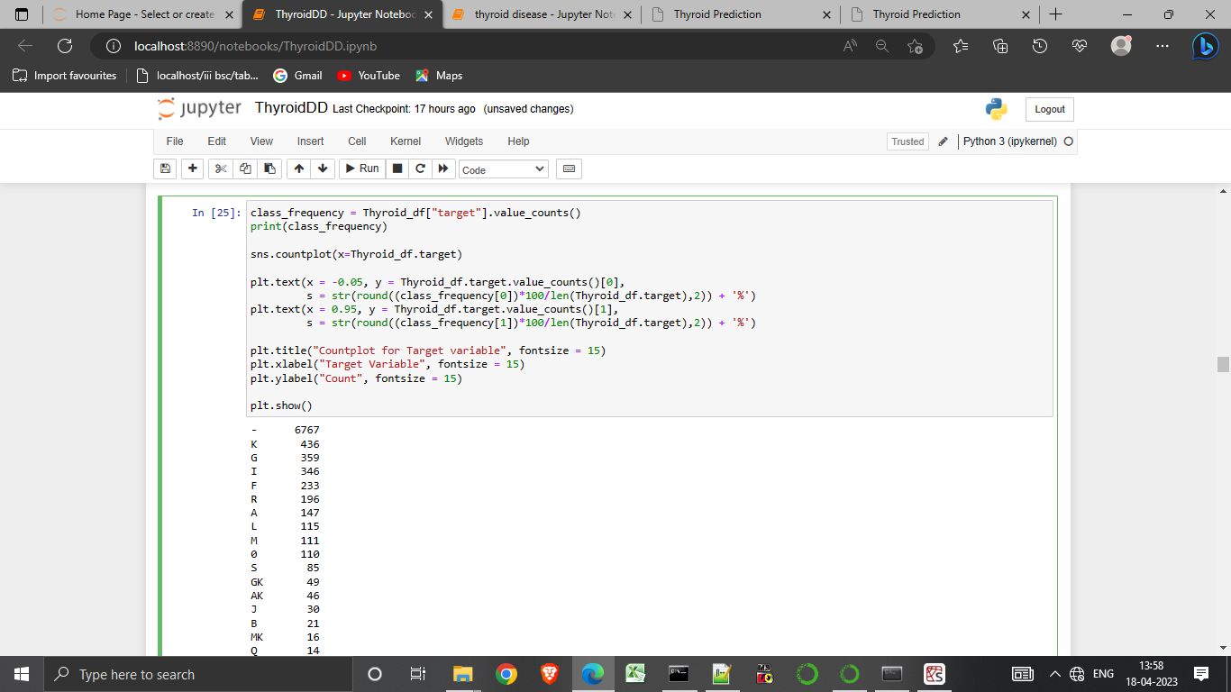

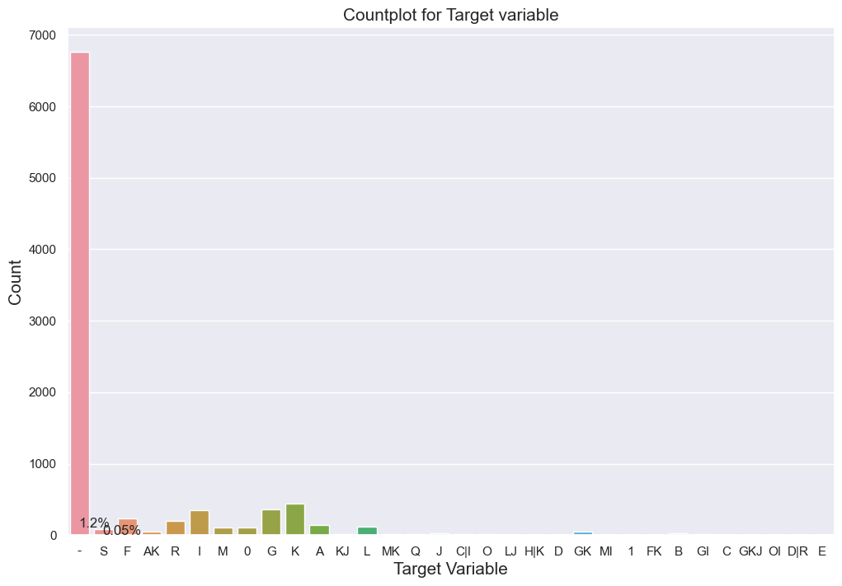

16.Using fig size to determine the sizes of the plot.

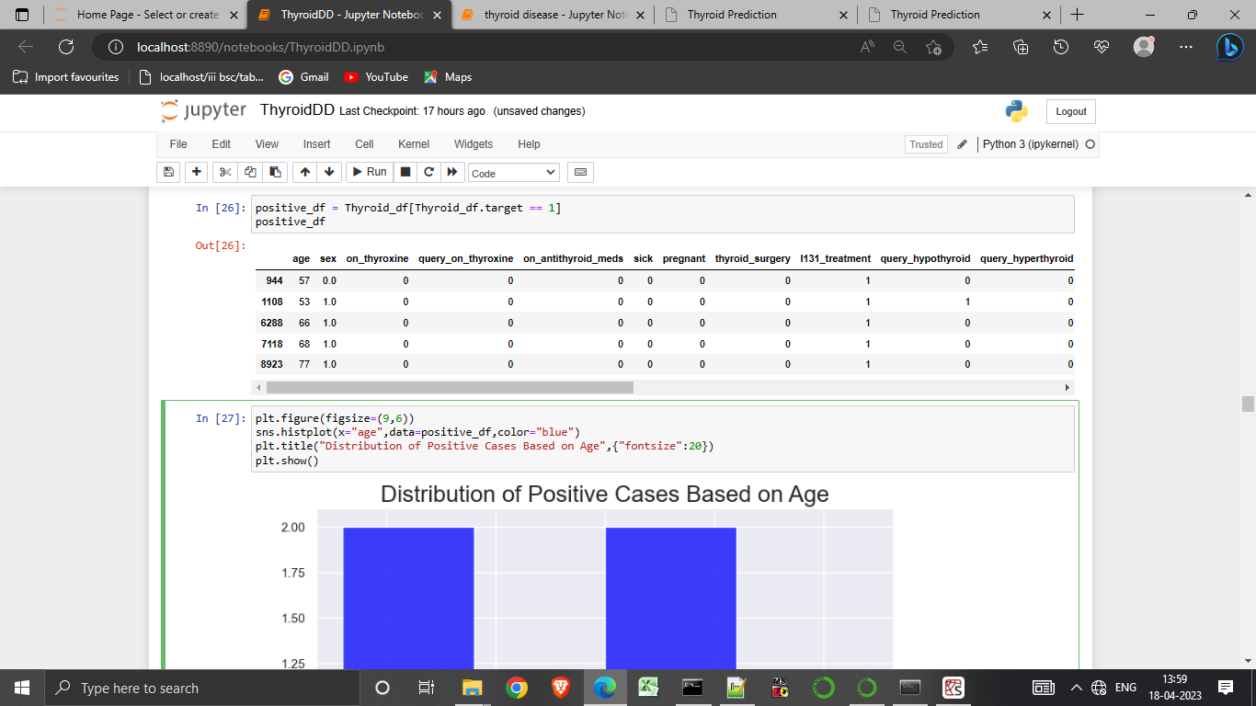

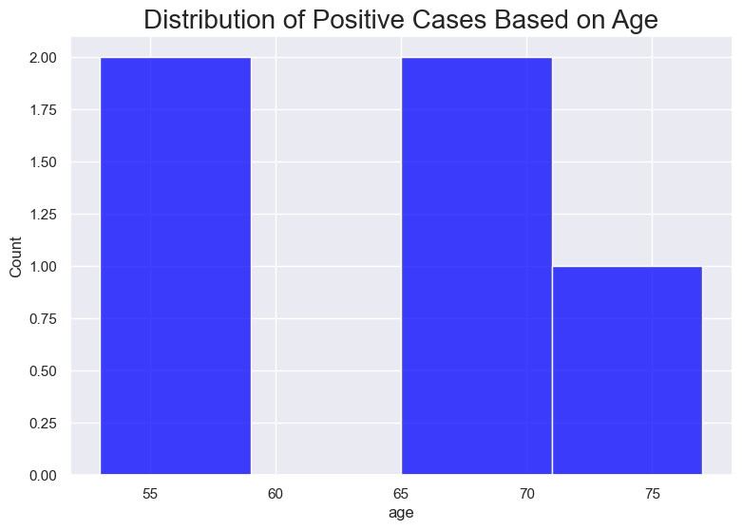

17. We taking sex.values as input to form a pie chart.

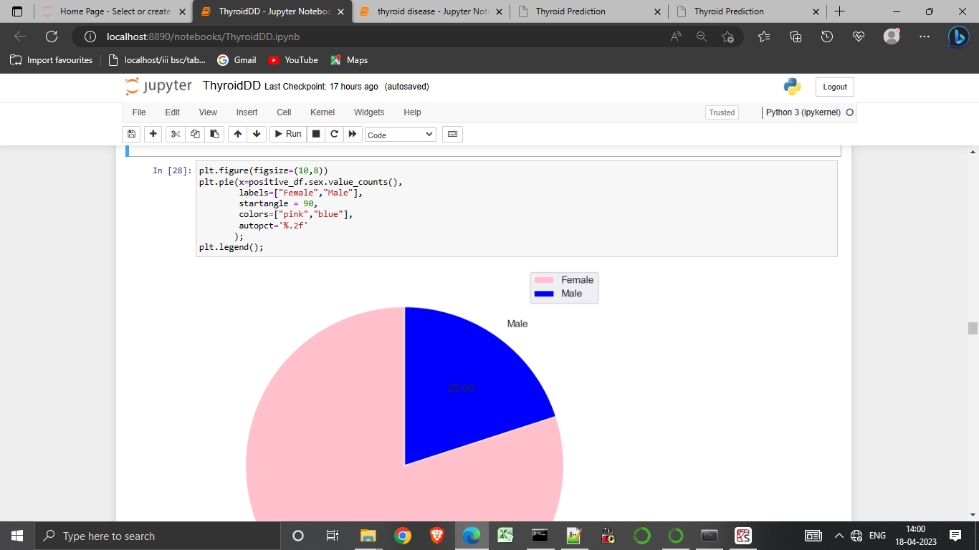

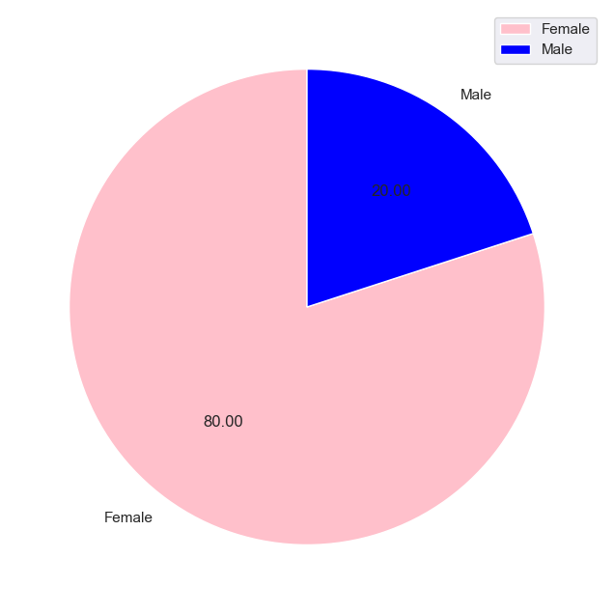

18.Use the corr function to generate the correlation matrix of the numberic varibles.

19.print the correlation matrix.

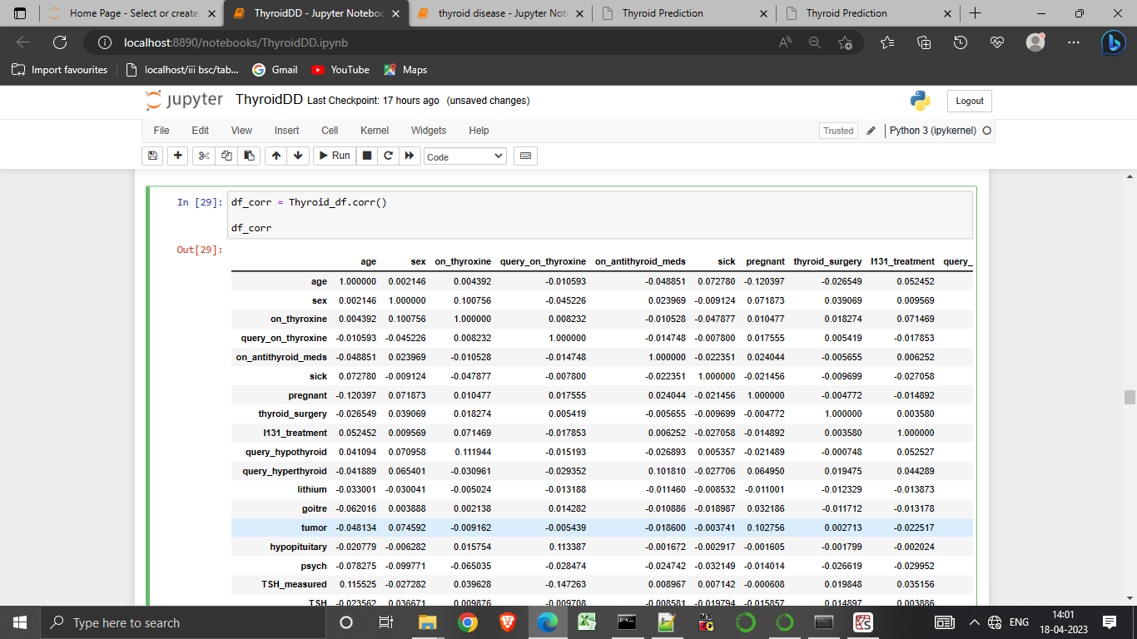

20.plot the heat map.

21.Using corr: give the correlation matrix.

22.Using cmap:color code used for plotting.

23.ylgnsu-yellow green blue.

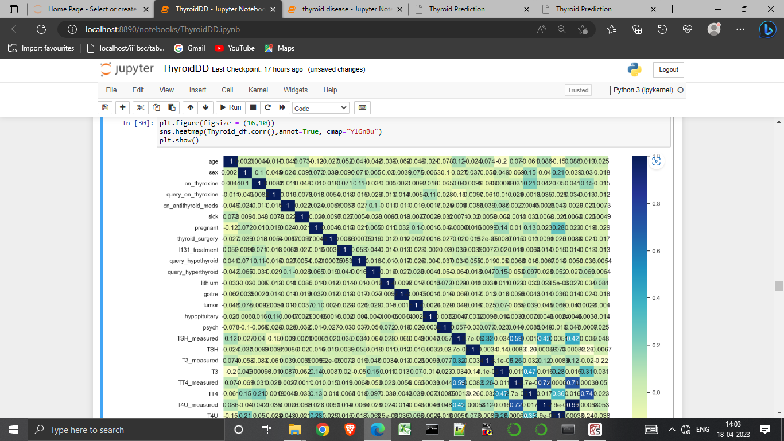

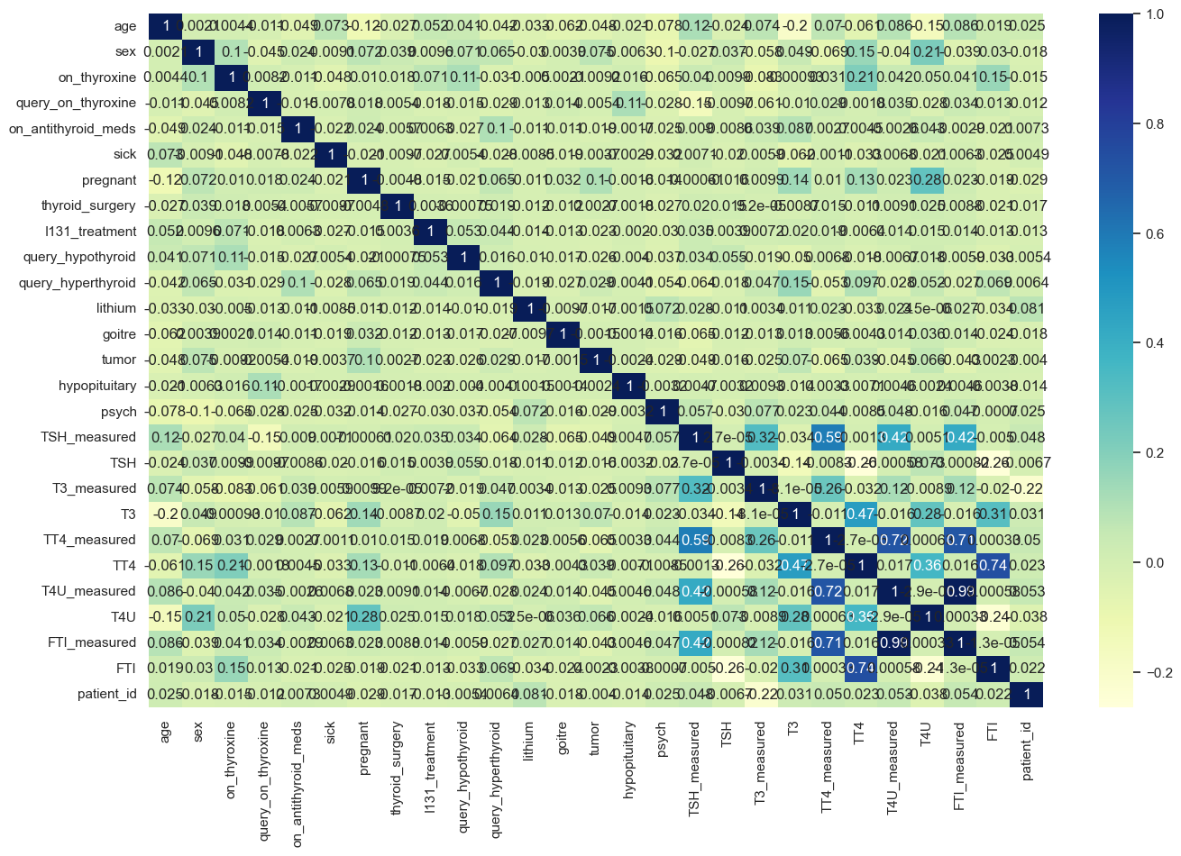

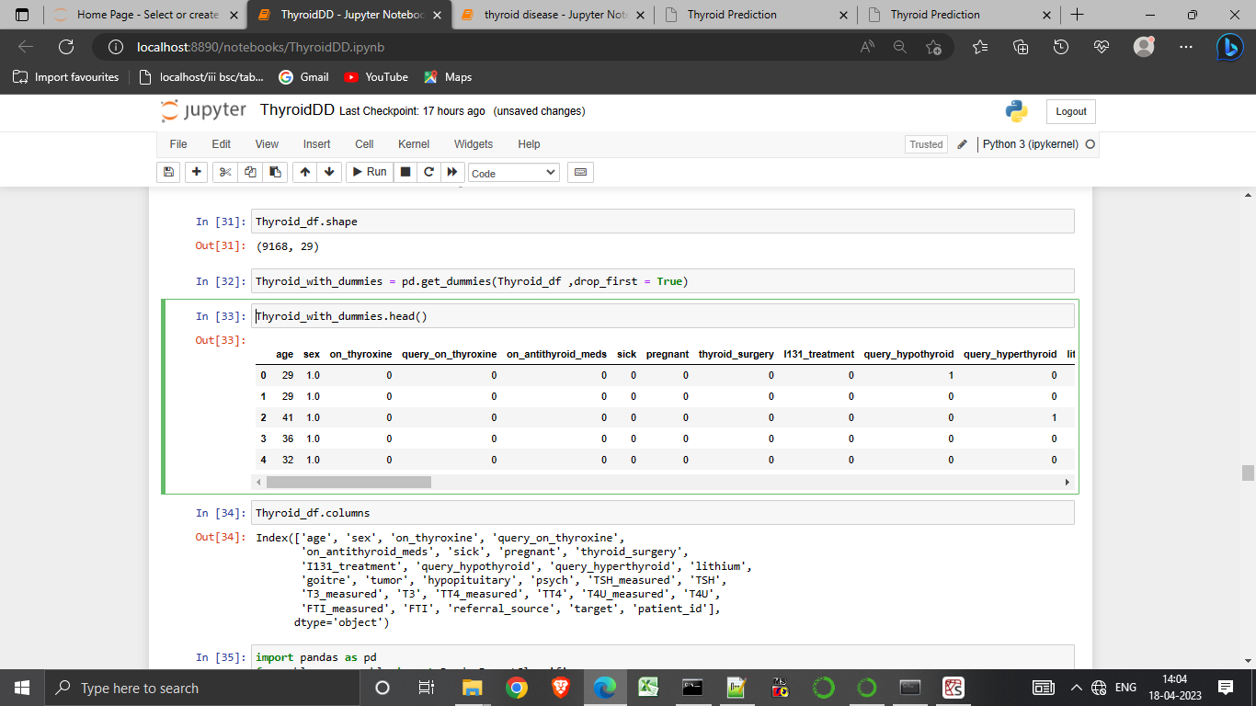

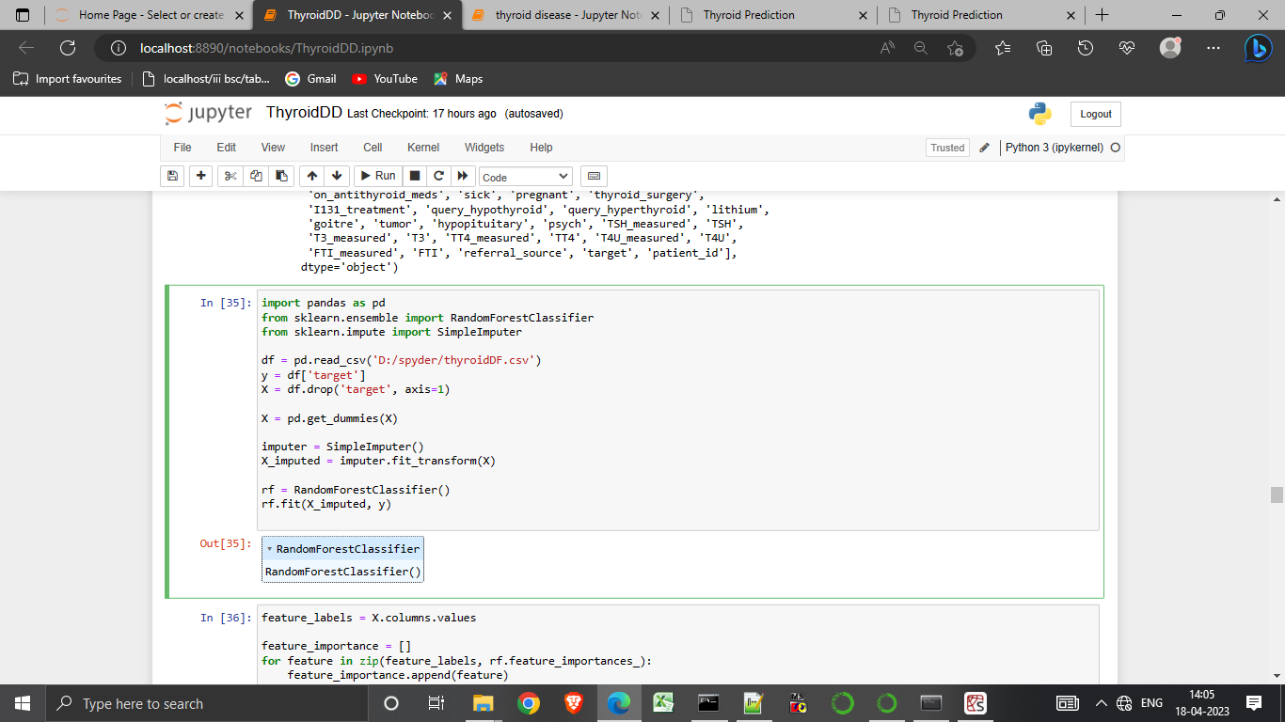

24.Creating a dummy files on X.

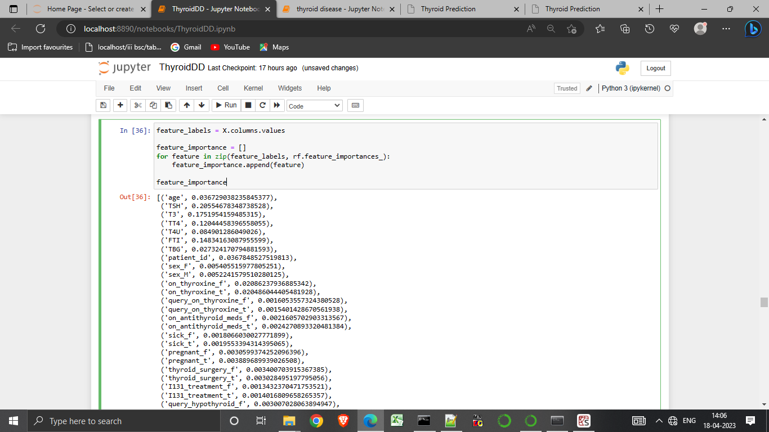

25.Using the features to display the random forest.

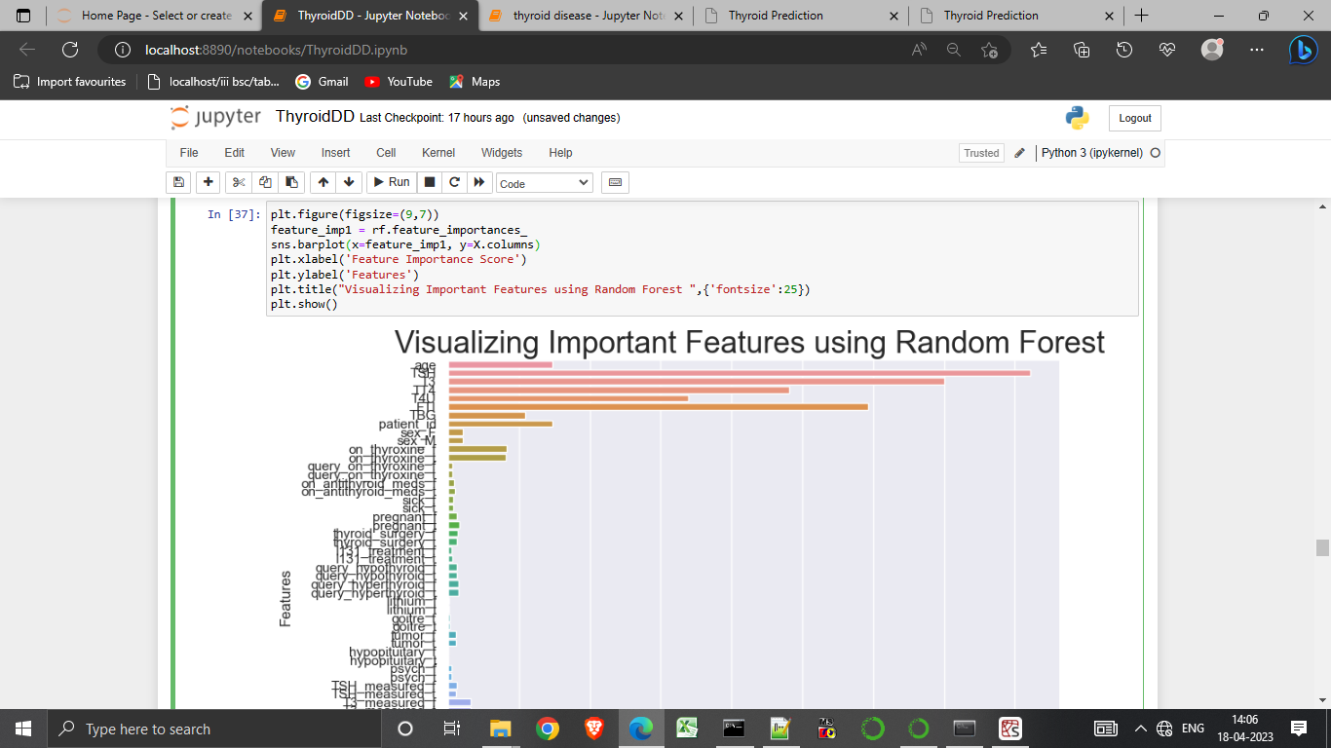

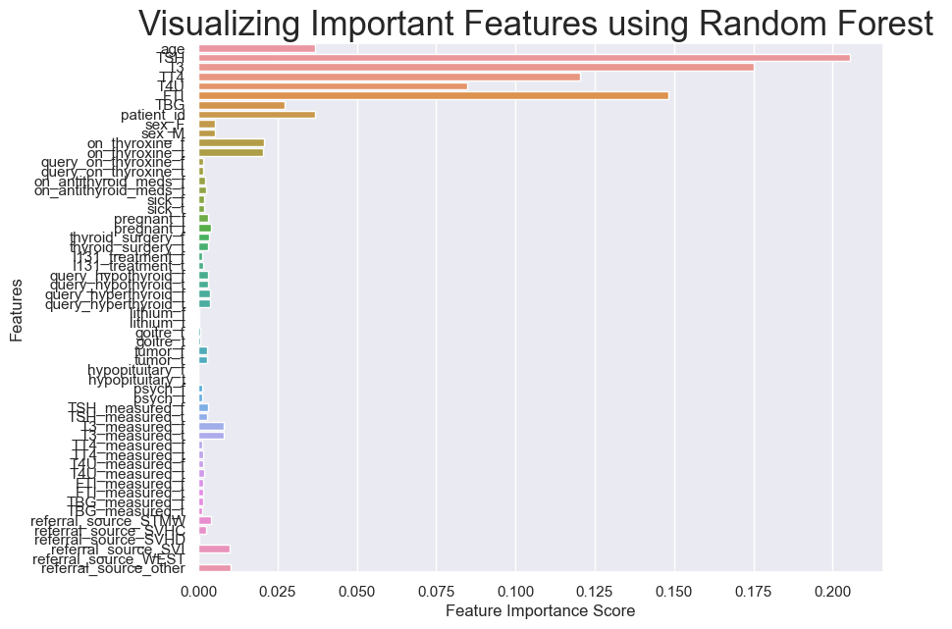

26.Using columns to display the columns of the data sets.

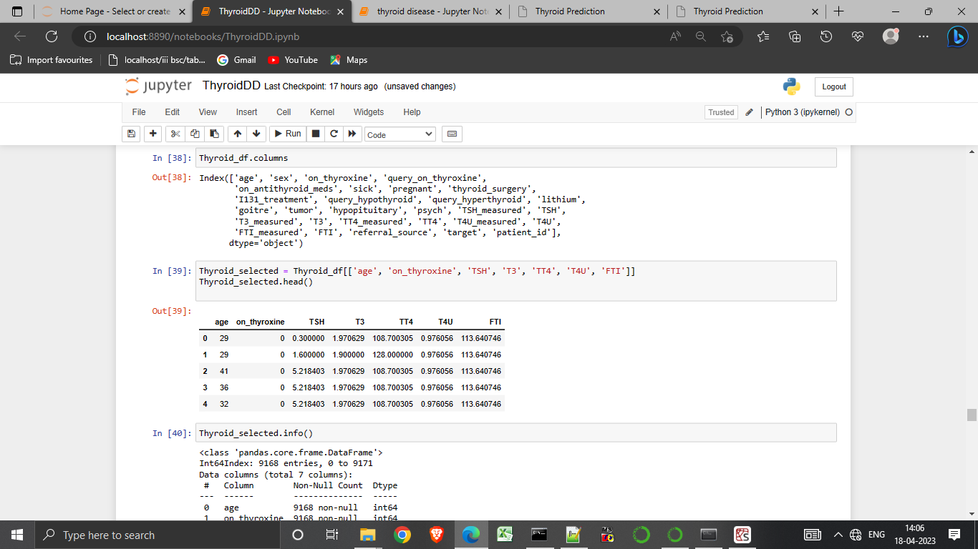

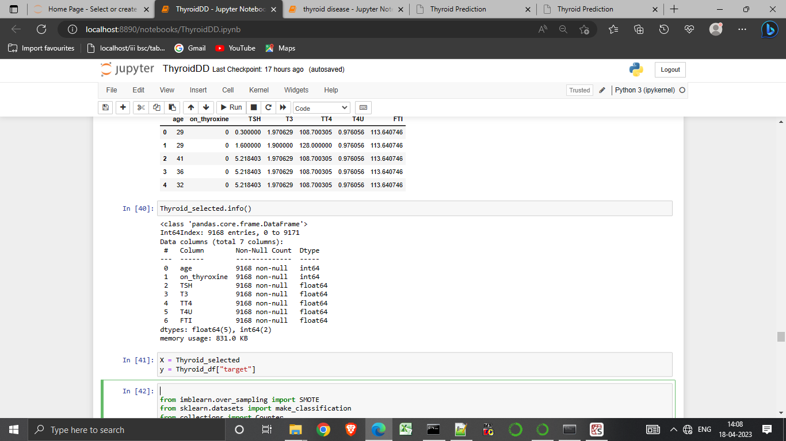

27.Taking “target” as both input x and y to form a count plot

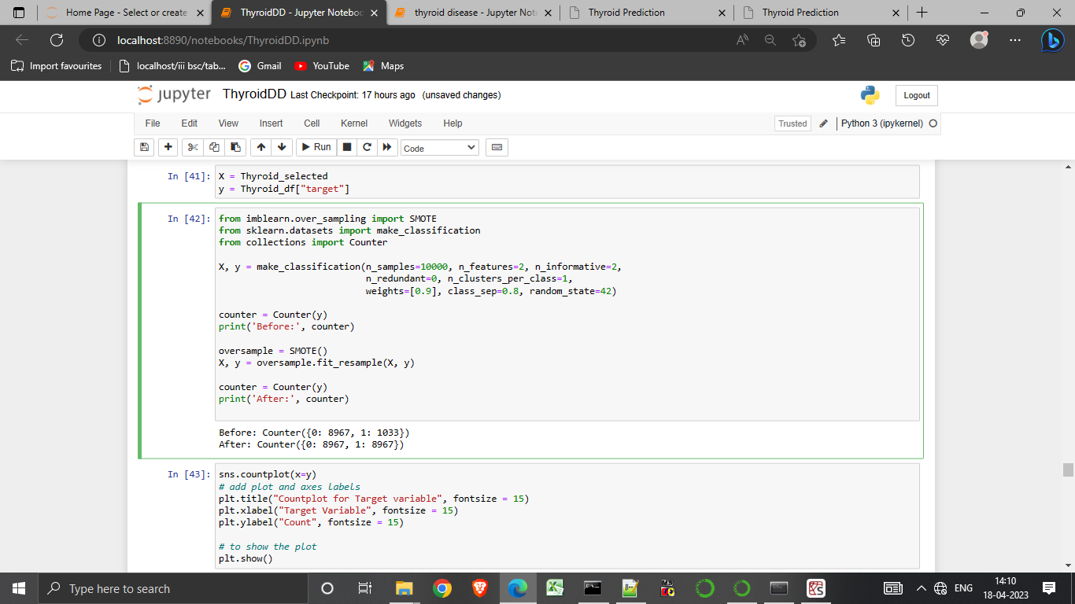

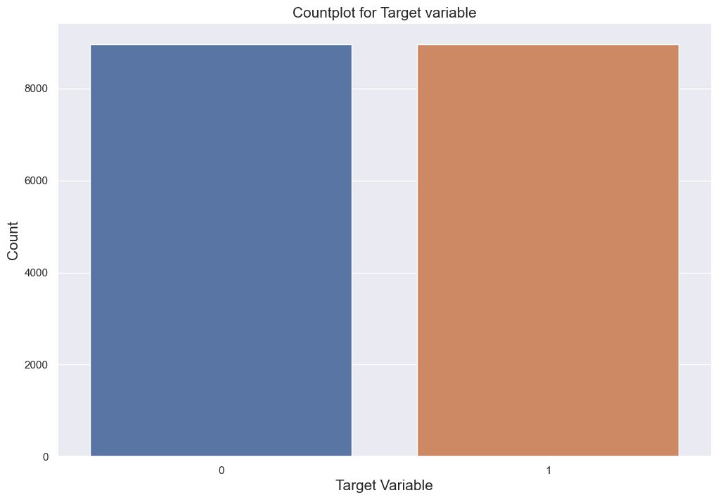

28.We using log regression , svm, knn, decision tree and random forest to create a model

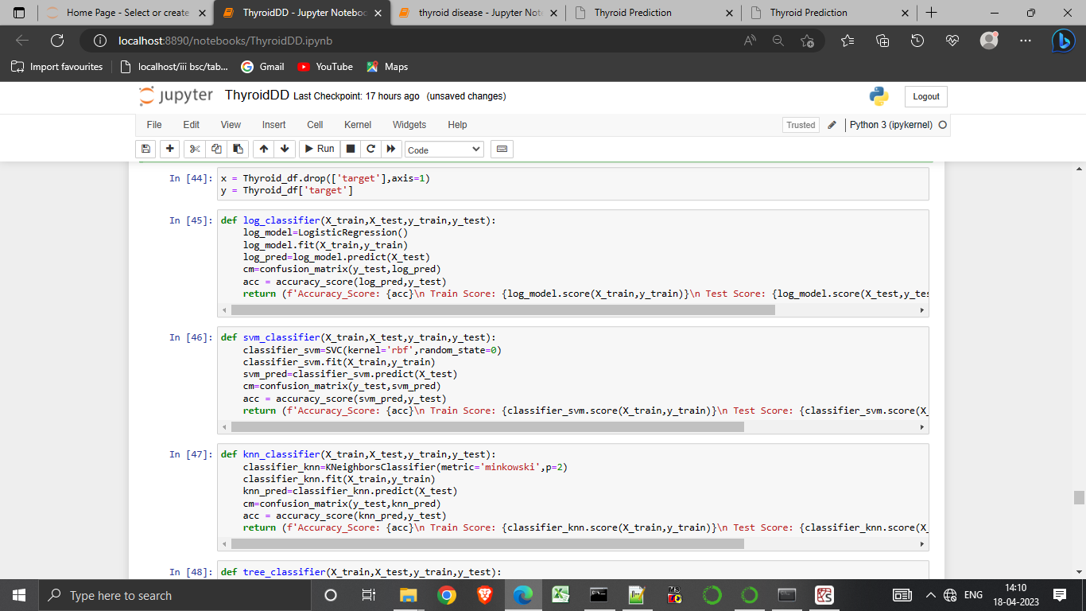

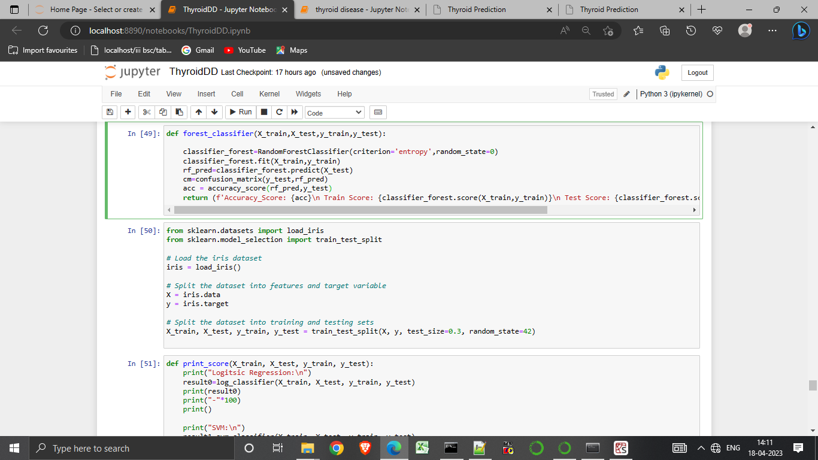

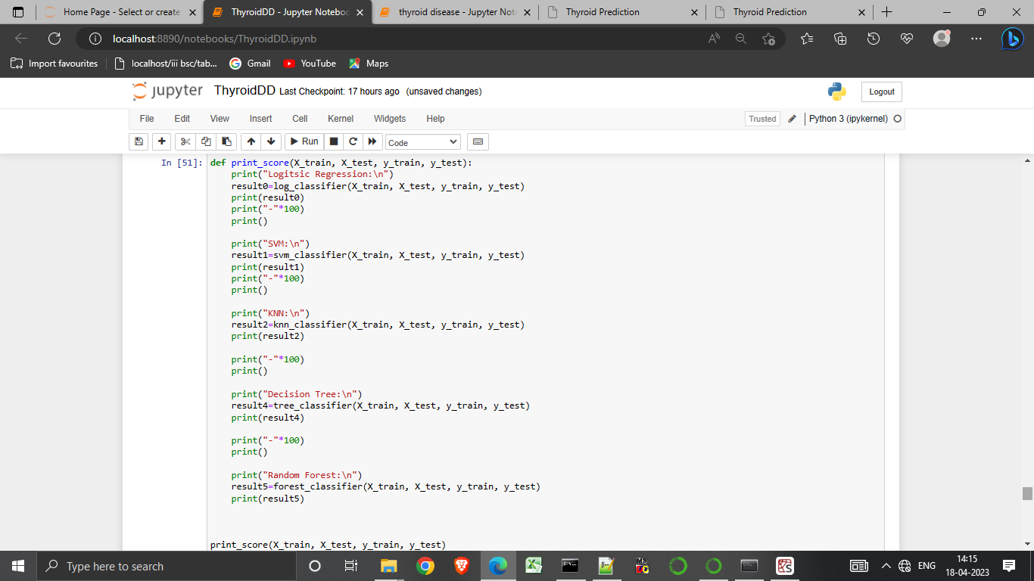

29.Using print_score to display the output of the given classifiers.

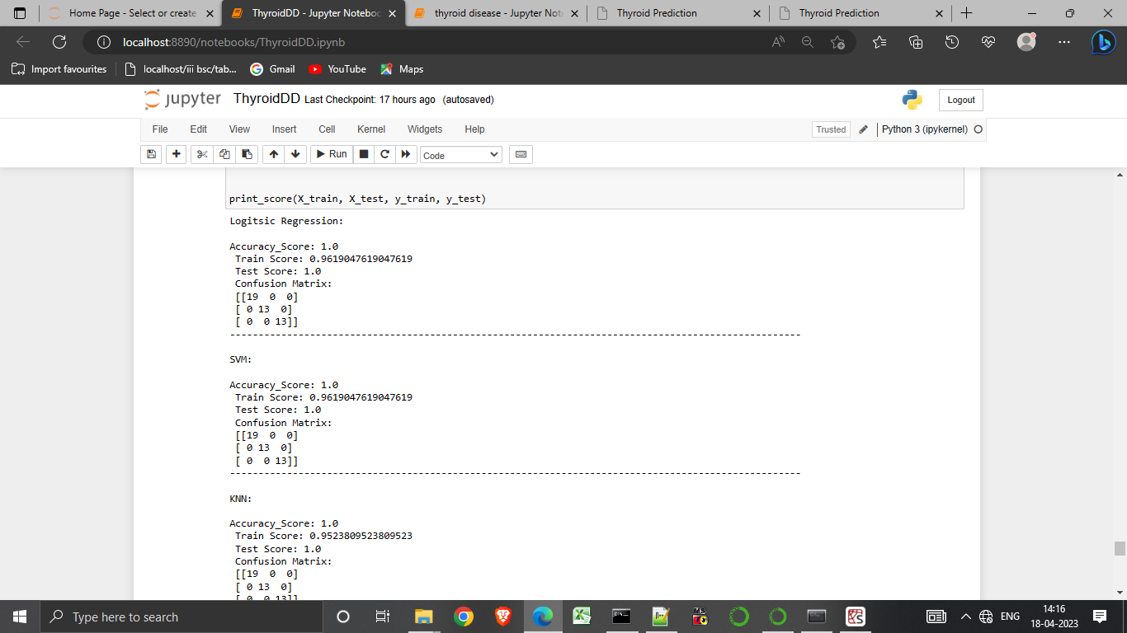

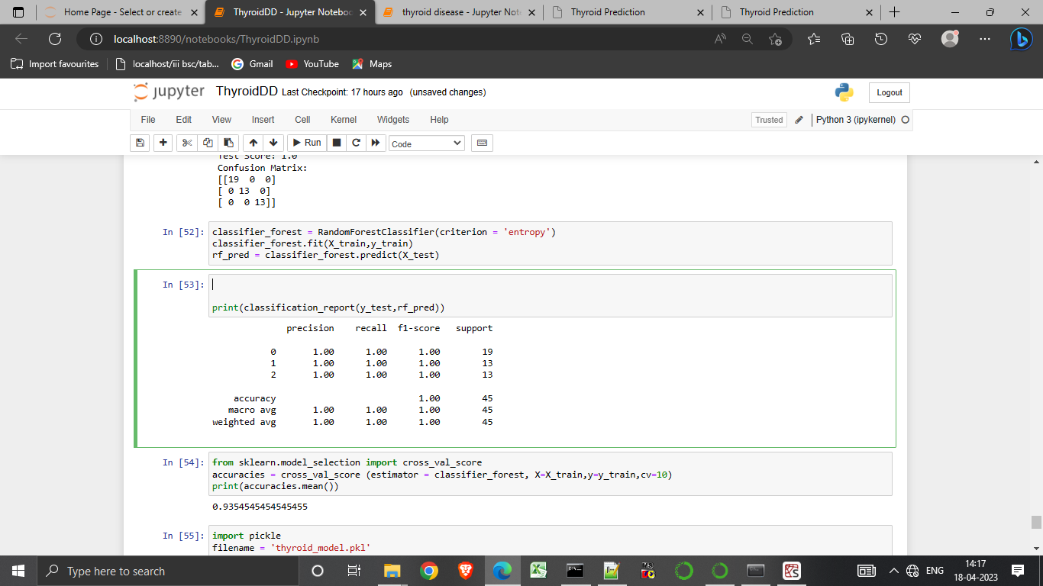

30.Using accuracy to show the accurate data .

31. Importing pickle to create a data model.

.

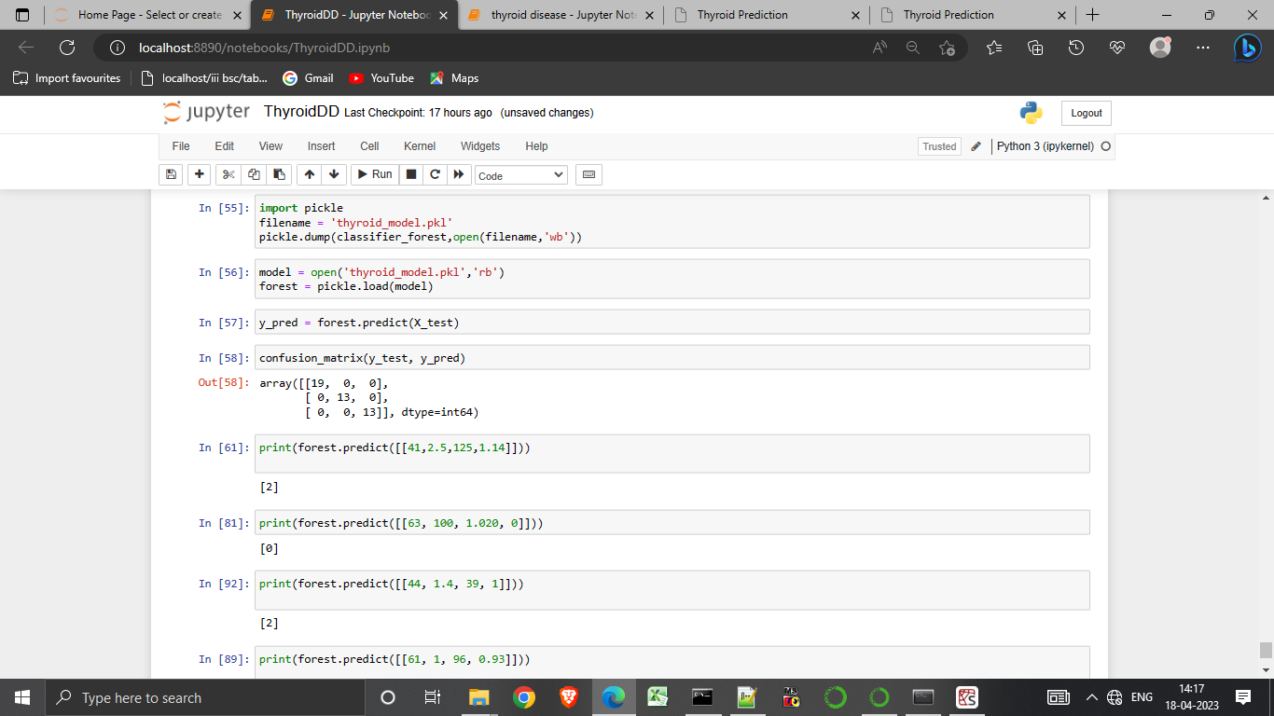

32. The final output will display in below format.

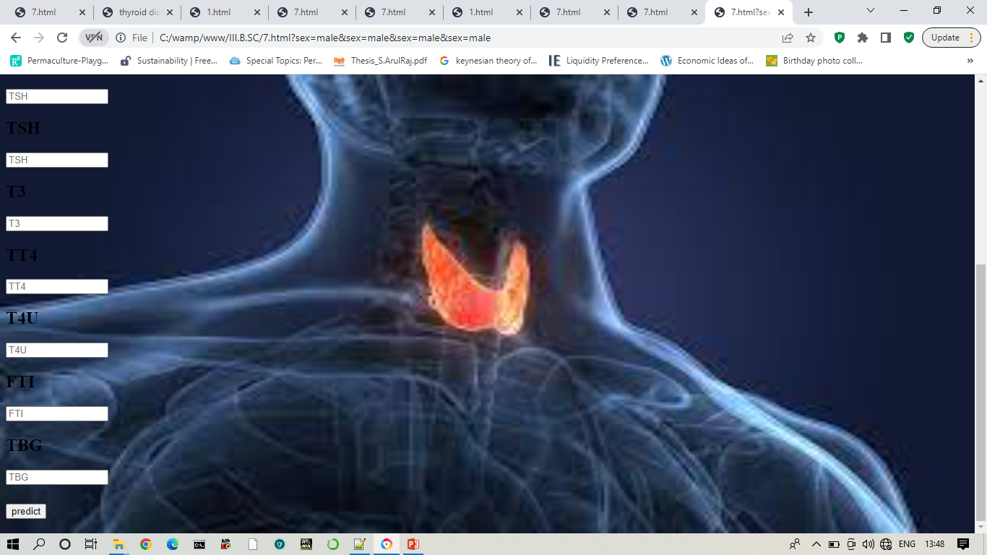

**4.Trailhead Profile Public URL :**

**Team Lead -****https://trailblazer.me/id/kishore25**

**Team Member 1 - https://trailblazer.me/id/bsuriya4**

**Team Member 2 - https://trailblazer.me/id/elango6374**

**Team Member 3 – https://trailblazer.me/id/vignb13**

**5.ADVANTAGES & DISADVANTAGE**

*ADVANTAGES:*

*1.Early detection:*

*A thyroid detection program can help detect thyroid problems at an early stage, which can lead to timely treatment and health outcomes.*

*2.Improved accuracy:*

*Thyroid detection program use advanced imaging techniques, such ultrasound, to detect thyroid problems.*

*3.Increase awareness:*

*A thyroid detection can help raise awareness about the importance*

*Of regular thyroid screenings.*

*4.Cost-effective:*

*Early Thyroid detection treatment can be cost effective in a long run,as can it prevent more serious issues.*

*5.Personalized treatment:*

*Thyroid detection program can help doctors develop personalized treatment plans based on a person specific thyroid condition.*

*Disadvantages:*

*1.False negatives:*

*The program may fail to detect some cases of thyroid disorders, leading to false negative results.*

*2.False positives:*

*The program may also generate false positive results, suggesting the presence of thyroid disorder where there is none.*

*3.Technical limitations:*

*The accuracy of the program can be limited in technical factor, such as the quality of the imaging equipment used, process algorithm .*

*4.Interpretation errors:*

*The interpretation of the results generated by the program can be challenging, and errors can be occur.*

*5.Lack of patient context:*

*The program may not take into account the patient’s individual medical history, family history, and other factors that can influence the developing a thyroid disorder.*

**6.APPLICATIONS**

1.Thyroid disease diagnosis:

The program used to detect thyroid nodule, goiter and other thyroid conditions.

2.Monitoring thyroid health:

Used to monitor changes in thyroid patients.

3.Research:

The program can be used to analyse large datsets of thyroid images and medical records.

**7.CONCLUSION**

A thyroid detection program is a powerful tool in the field of medicine that can aid in the diagnosis, treatment planning, and monitoring of thyroid conditions.

**8.FUTURE SCOPE**

1.Integration with electronic health records(EHRs):

By integrating with EHRs, thyroid detection programs to access a patient details.

2.Use of 3D imaging:

3D imaging technology could provide more details and accurate information about the thyroid gland.

3.Developement of mobile apps:

Mobile apps that use a smartphones camera to take

Pictures of the thyroid gland could provide a low cost and Convenient screening tool for thyroid disease.